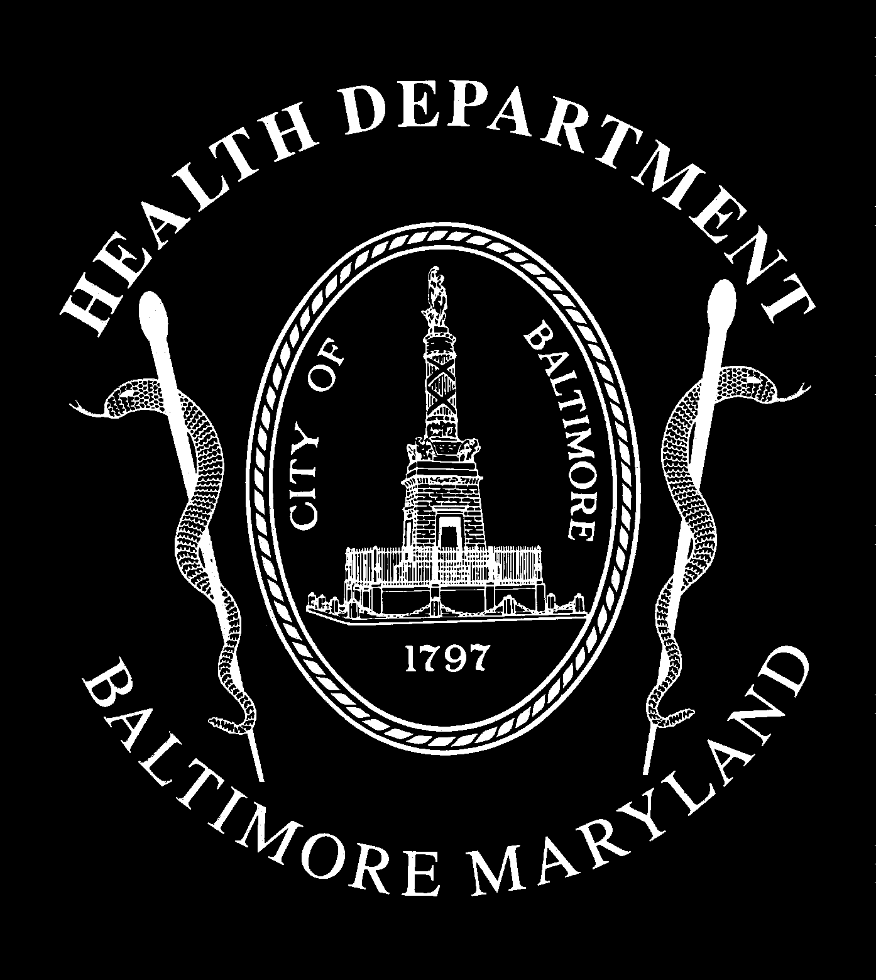

CITY OF BALTIMORE

STEPHANIE RAWLINGS-BLAKE, Mayor

HEALTH DEPARTMENT
Leana S. Wen, M.D., M.Sc., FAAEM
Commissioner of Health
1001 E. Fayette St.
Baltimore, MD 21202
Website: health.baltimorecity.gov
Tel: 410-396-4398

Mayor’s Heroin Treatment & Prevention Task Force
Recommendations – July 2015

- Develop dashboard for ongoing monitoring to obtain real-time data for number of people with substance use disorders, near-fatal and fatal overdoses, and capacity for treatment.
- Implement citywide heroin overdose plan to save lives of our citizens. This plan includes developing targeted treatment and preventive interventions for those at highest risk for overdose and ensuring widespread dissemination of the opioid antidote, naloxone.

- Develop a centralized, easy-to-access intake that is 24/7, with immediate access to an addiction counselor or social worker, and publicize to all (including emergency departments, emergency personnel, peer networks, and community members).
- Increase data-driven, high-impact options for treatment. This includes universal case management and access to treatment for most vulnerable individuals in the city such as inmates and the recently incarcerated, as well as increasing availability of evidence-based treatment, such as buprenorphine.

- Ensure treatment on demand. This includes work towards a 24/7, “no wrong door” treatment center for addiction and full capacity for treatment in both intensive inpatient and low-intensity outpatient settings.

- Develop voluntary certification and review for substance use providers based on core standards of care. This includes a pilot to test and refine best practice standards with key volunteer providers in Baltimore City.

- Facilitate an ongoing partnership and collaboration among key stakeholders to pilot programs, test economic incentives, and discuss integration with state/federal systems of care.

- Develop standardized good neighbor agreement and establish best practices for substance use disorder providers and community members (including issues such as loitering, cleanliness, security, community advisory committee, and voluntary agreements).

- Coordinate efforts with treatment providers and law enforcement. This includes preventing targeted drug sales to vulnerable individuals undergoing addiction treatment; working collaboratively to obtain help for people with behavioral health disorders; and increasing support for Drug Treatment Courts and other diversion programs.

- Implement comprehensive strategy to educate and inform residents, businesses, and other key stakeholders about substance addiction to help reduce fear and combat stigma. This includes launching a campaign to educate citizens that addiction is a chronic disease and to encourage individuals to see treatment.

